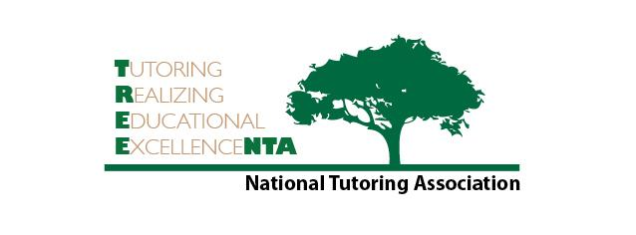

National Tutoring Association
Basic Level Tutor Assessment

NAME:

- What is the definition of tutoring?

- List 3 benefits of certification.

- List five qualities of an effective tutor.

- What are the three pillars of the role of the tutor?

- List four strategies for using praise effectively.

6. Why is the correct use of praise important in the tutor/student relationship?

- Define andragogy vs. pedagogy.

- List the three skills needed for effective communication and provide one strategy to improve each skill.

9. Describe three examples of para-verbal messages.

10. How can we evaluate the efficacy of tutors, tutoring sessions, student achievement, and tutorial programs?

11. How does FERPA affect tutors both in institutions and in private practice?

12. What did you learn from this Basic Level Webinar and what do you commit to include in your tutorial cadre of skills?

